VM – Capturing image

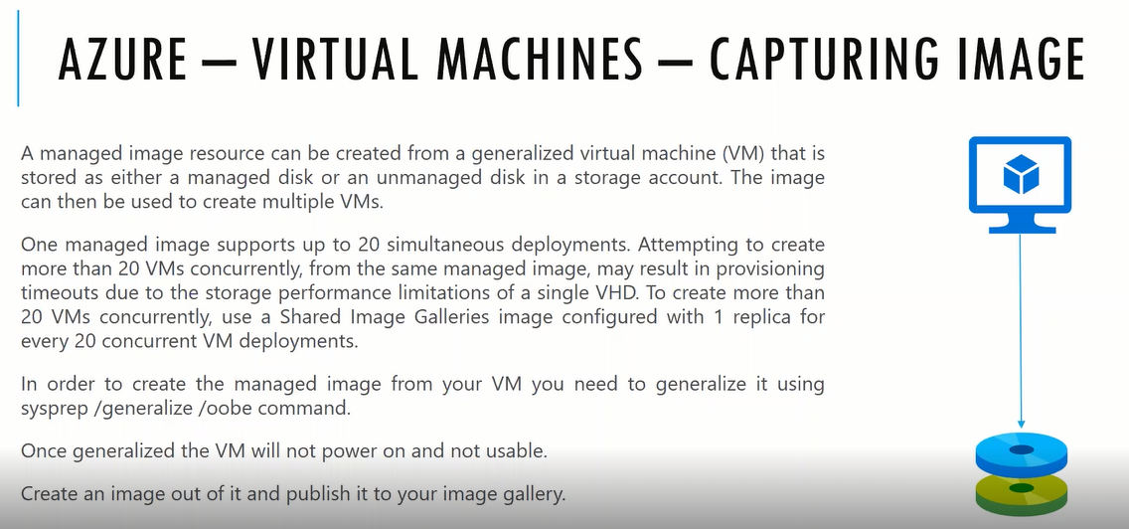

for particular VM we need to create the image as of now we are using the images which is provided by Microsoft there is no custom images if you want to create the custom images we need to follow the Capture

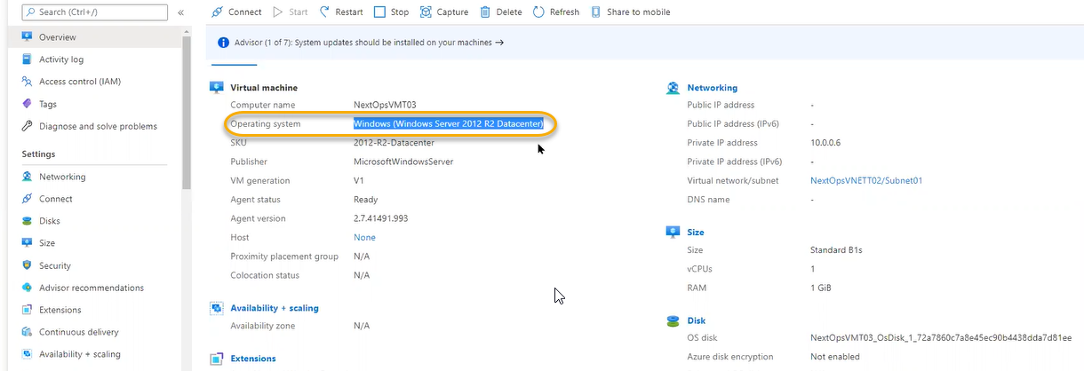

we will login to the VM and do necessary configuration automatically browsers will be installed in the final step this machine configuration O.S Point of view total configuration we need to reset this

from machine to another machine we have unique identification with that unique identification we see the difference in network

before creating we need to run the sysprep in the O.S if not that VM will not be started from image

generalize is mandatory requirement for capturing process

if Microsoft will give the original image we can create more than 20 VMs. We have created the VM in Azure which is not under our control and it will store somewhere in Microsoft storage and any number of requests azure will handle it and store in high redundancy infrastructure

our created image from our subscription level for VM will be stored in our storage account in the file

storage accounts have limits from one subscription to another subscription

once created the image the main VM will be dead

create the public Ip if it is not associated with VM

How to associate public Ip

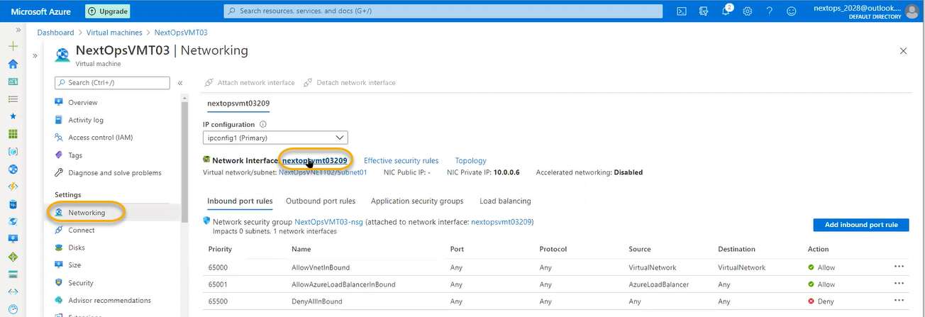

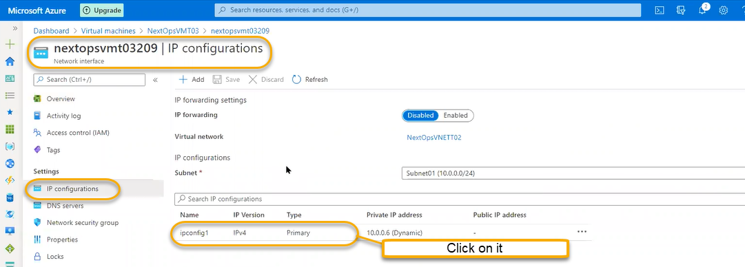

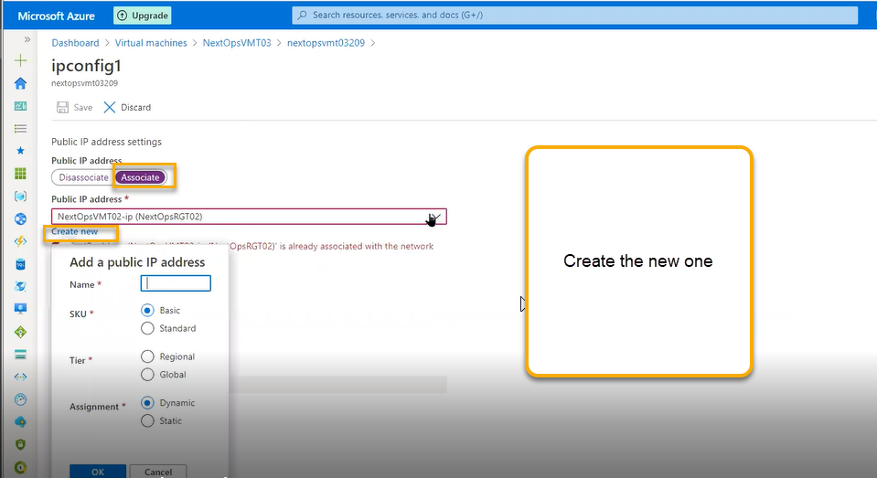

Provide the name and click on ok and again click on Save

From this standardization operating system with tool set we need to create the image On premises we will get this type of tickets

So that public Ip will be created

Connect to VM Machine via RDP using public IP

We can save images specific to our repository or if you want to share any market or community we can do by using shared image gallery

We will install one web server

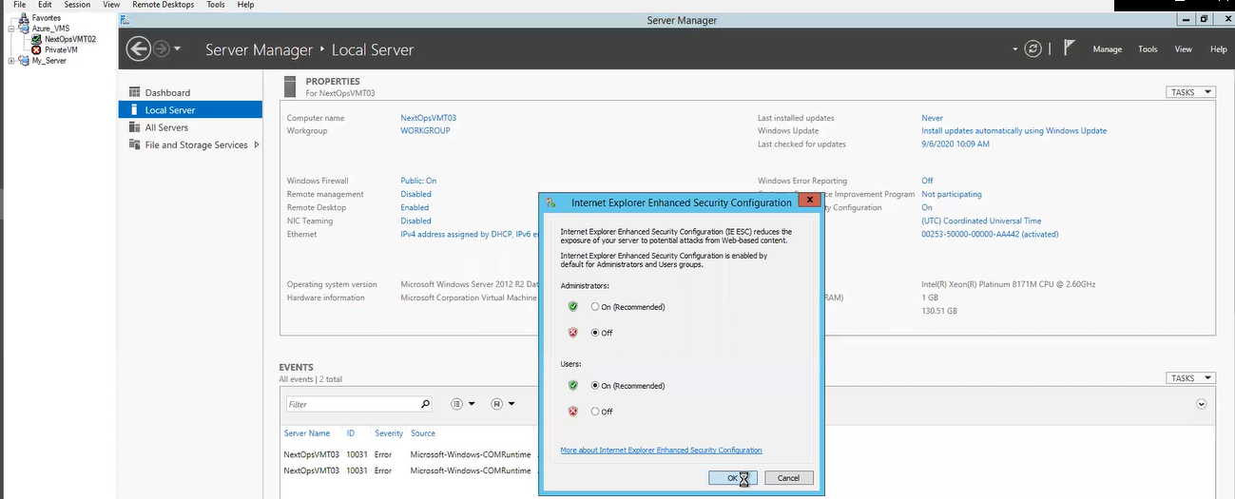

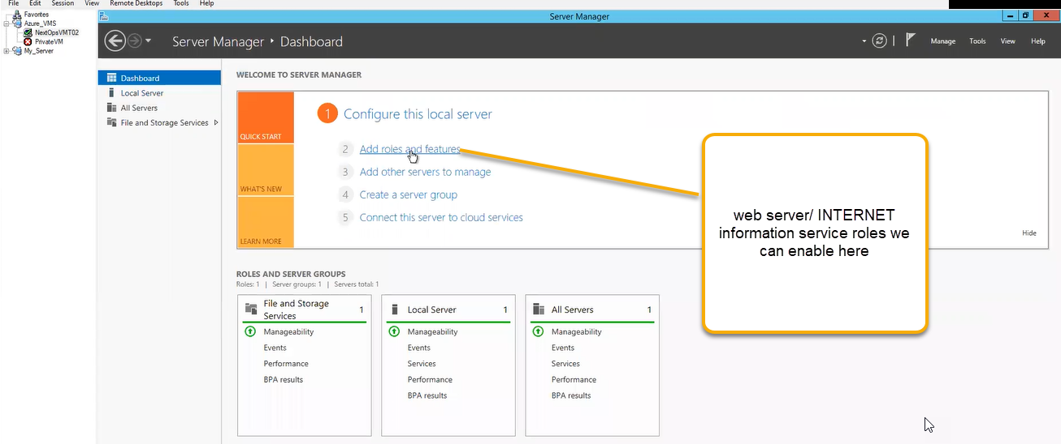

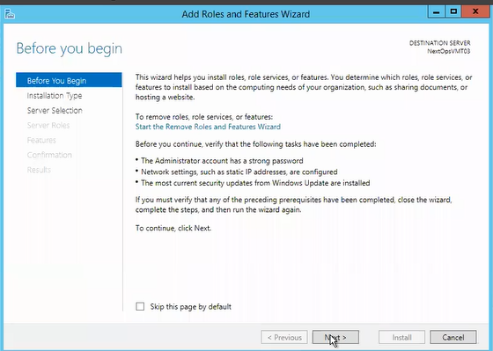

Click on Next > Next >

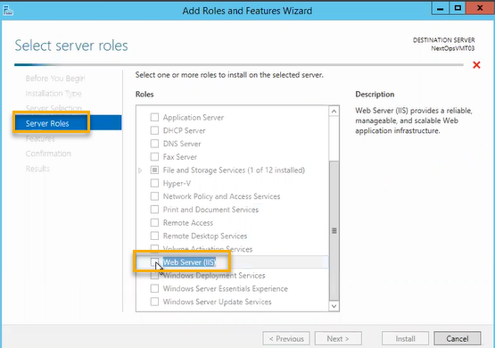

Click on Next > Next and Click on the install

We are installing the web server along install the internet explorer so that if is image is captured from this VM and the same image if we redeploy it will applicable to all the VMs

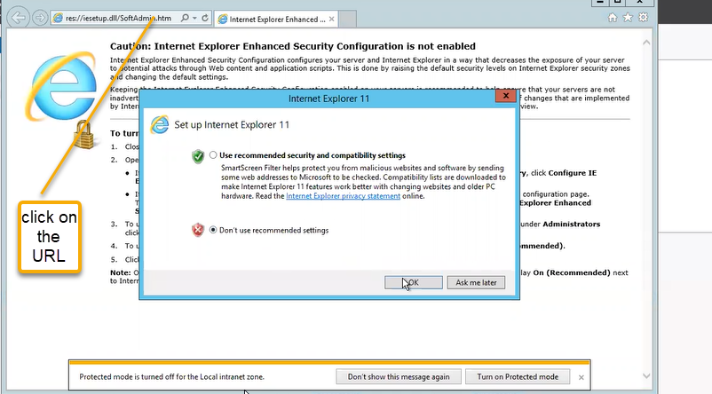

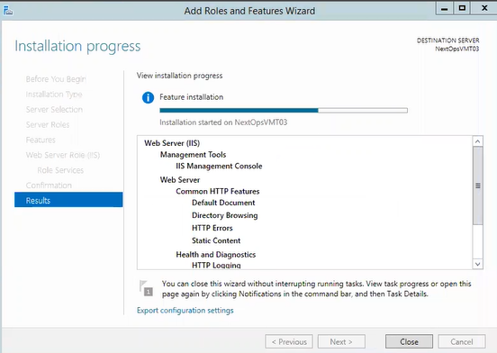

Wait for few minutes to install

Run the below query system preparation tool pop up will appear

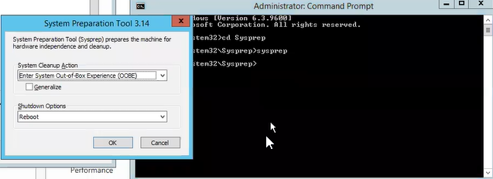

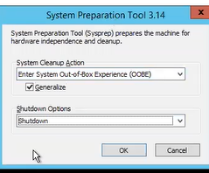

Networking configuration will be reset completely there is NO IP in place and also system related GUID will be there because of those Ids in the organization we can see the difference on each system

If you don’t shut down or does not run the command in the sysprep and if we create a 100 image for this VM then for all 100 images there will be same GUID will be assigned to 100 images/ VMS

Because technology point of view it will show as single entity and there will be security problems after running the sysprep network configurations will be reset windows activation related will be reset and identifications will be reset

If you google the local host it will show the web server IIS since we have installed it

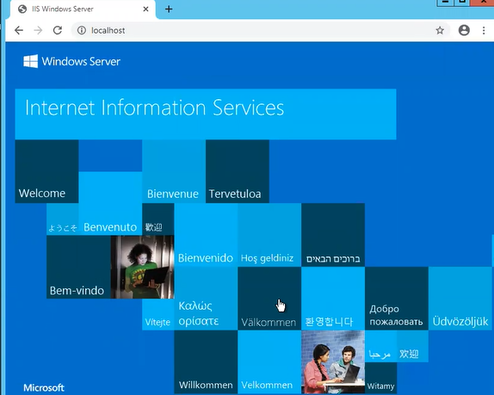

We can actually shutdown the VM using the CMD

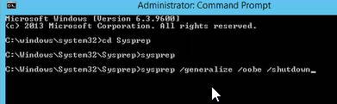

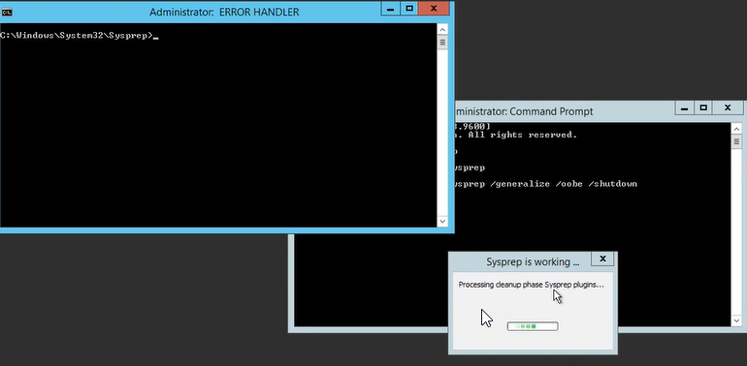

This is know error in windows 2012

BELOW IS THE Process for creating an image. Go to Virtual machines >> overview >> click on capture symbol

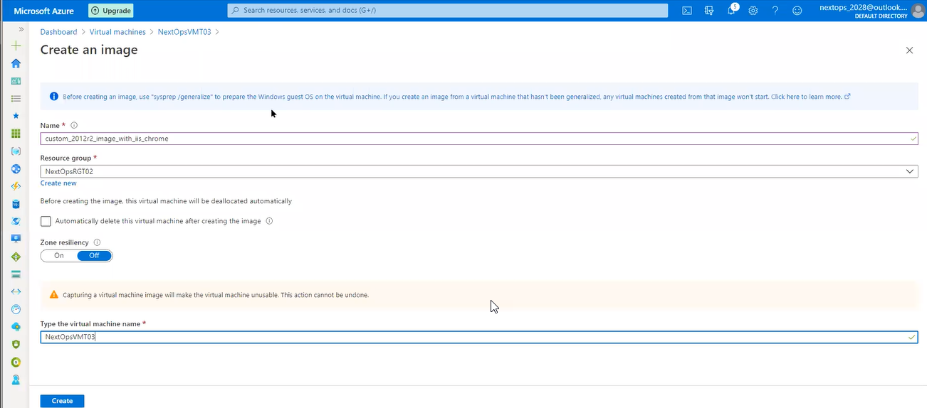

Once it is done we can do the capturing process click on the create



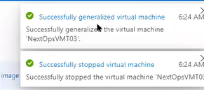

We can see the created image as the resource below

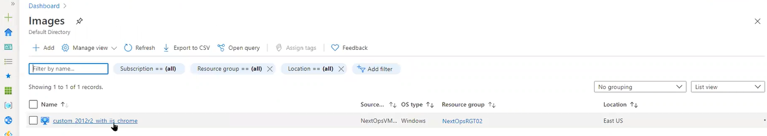

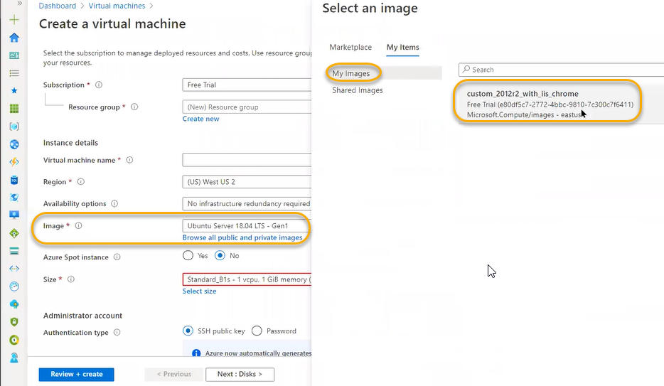

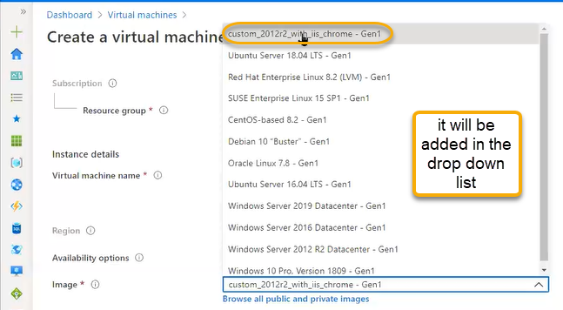

Shared image galleries

Created image is in East Us region and if we need to place the same image in the india or if you are creating an VM in india and our image is in East US we can do that using the Shared image galleries

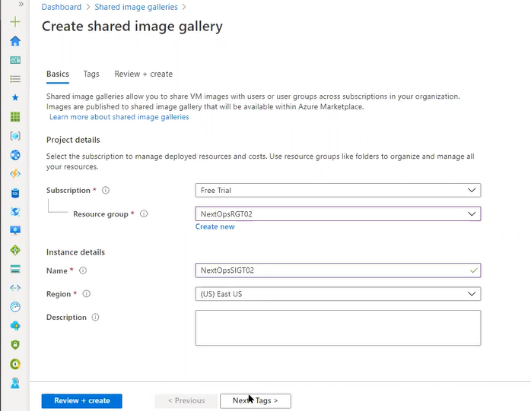

Click on create and create and finish

Which image we want to replicate the size will be 128 gb ( we replicating the same image from east US location to india )

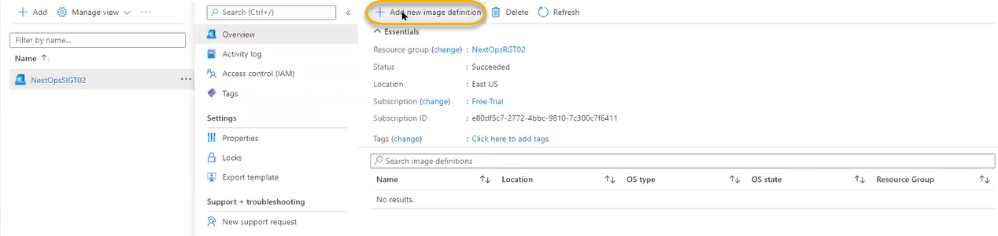

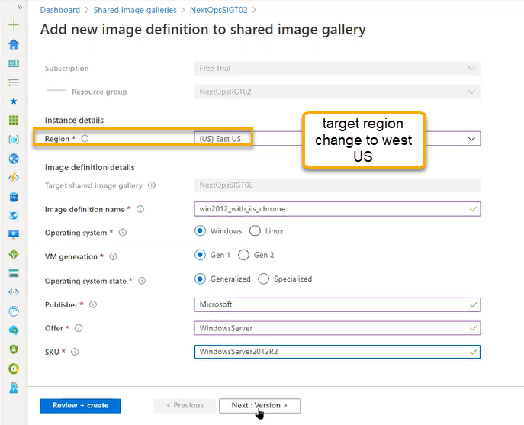

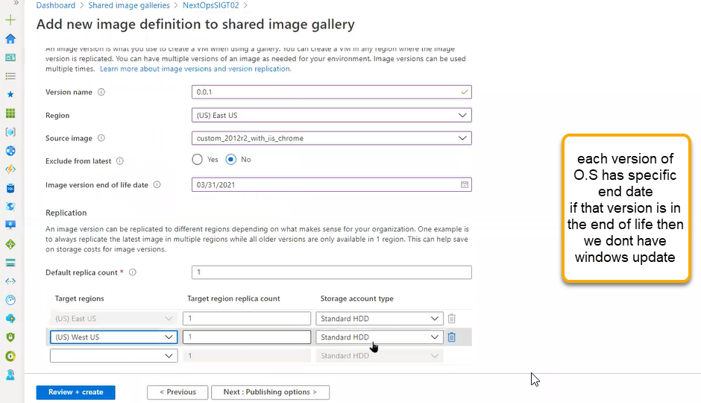

EULA : End user license agreement

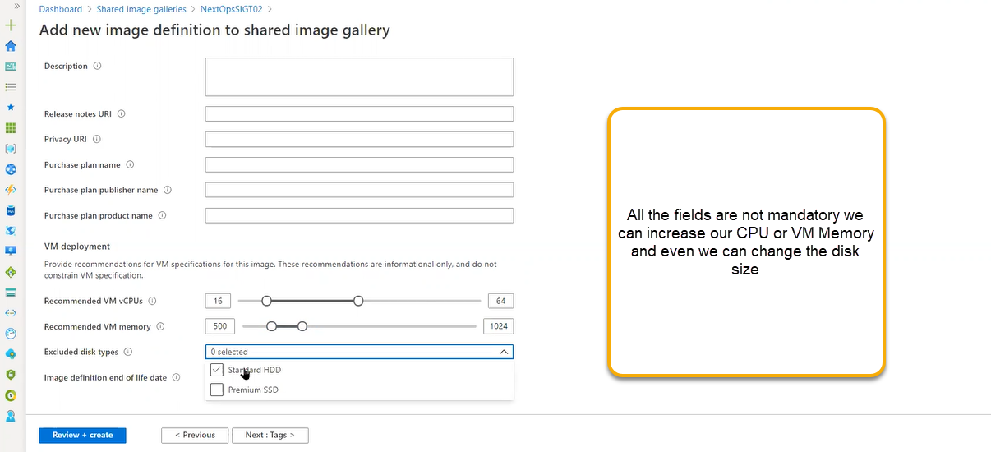

**Click on create and next and create**

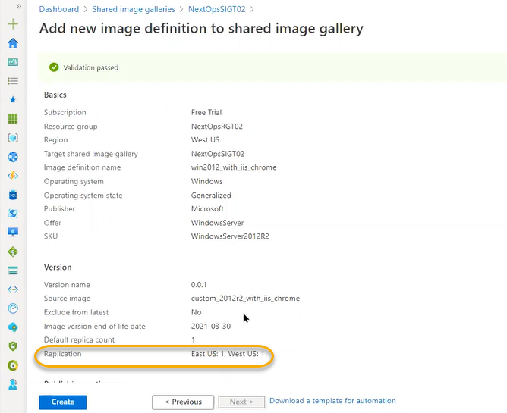

As highlighted above Replication is started from EAST US to West US. Click on create

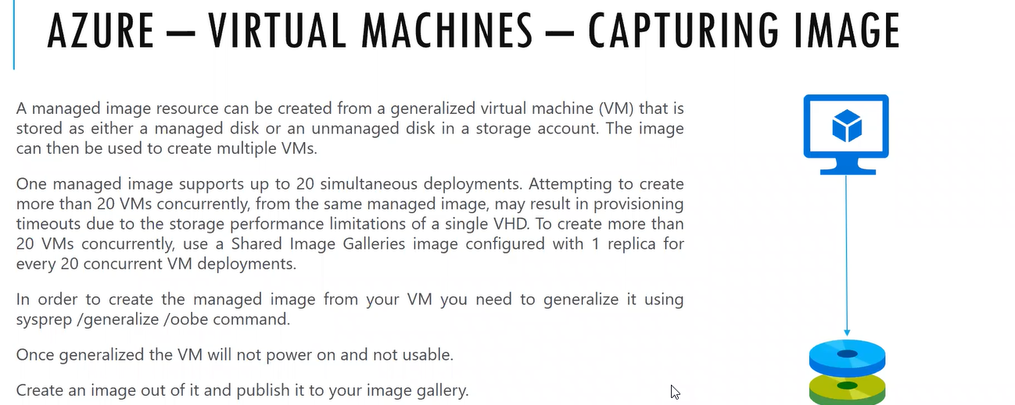

Reservations

Spot instances is cost saving option. Resources are not guarantee when demand will go for pay your go customers automatically the resources will be terminated if you need cost saving and resources we will use reservations

Only in the VM level we can do this

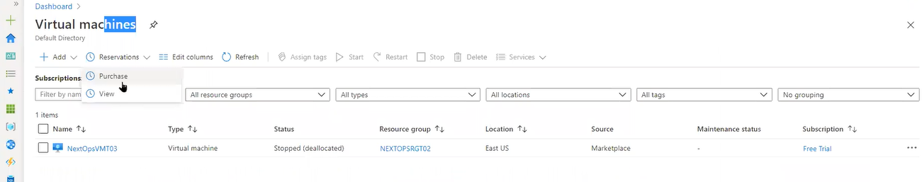

Reservations is the combination of spot and pay as you go

72% cost will be saved if you select this option

As a customer we will give commitment that will use continuously it might be 1 year or 3 year contract so that they will discount and they will reserve the capacity

We will reserve the VM with B1 size and we need to switch to another size we can do with in the same B series range

If you want to reserve, click on the purchase

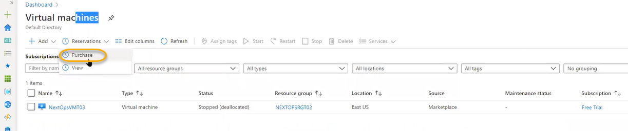

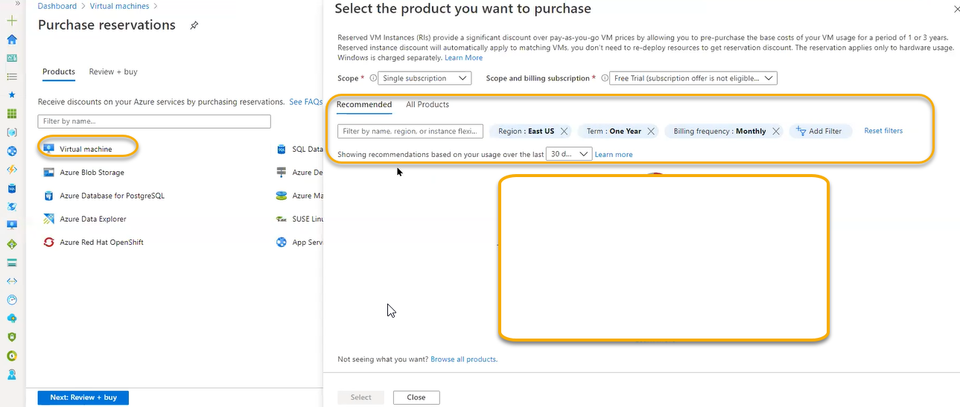

If you pay (Billing frequency) is monthly or yearly then there is NO effect in the cost

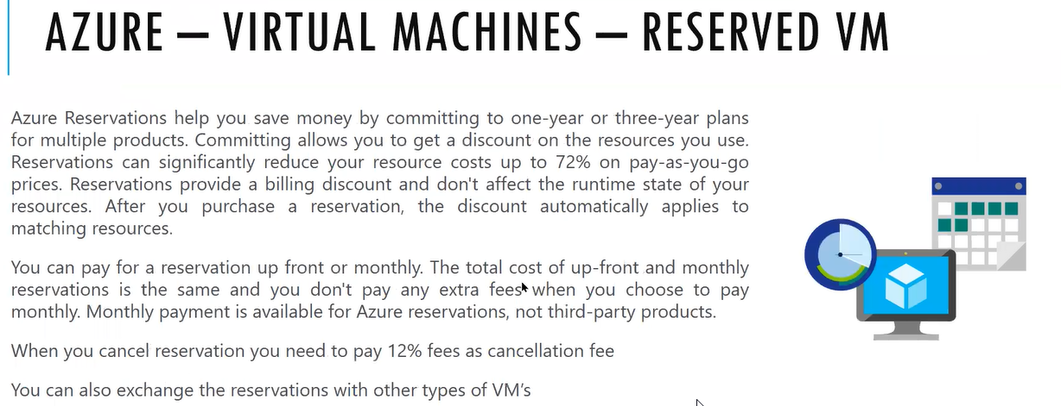

Scale sets: scalability supporting resource

We have created one image that image is running on the standard configuration installed the web server and chrome if we create the same VMs multiple times in the multiple created VM if we run the same web application

IRCTC: Certain time we have peak load in that time infrastructure will be peak load VMS will be increased more number if there is no peak time the VM will be deleted automatically and scale back

Generally, this process is automation from the custom image if we define the scale set and if you define maximum number of VMs (two options will be there one is automatic scaling and manual scaling)

That 10 VMs will be automatically created if you select the option

VM Panel only VMs will be there and the VMs present in the scale set it will not visible here the scale set VMS we can access only from scale set

Scale set will be placed behind the load balancers which will distribute the load using load mechanism

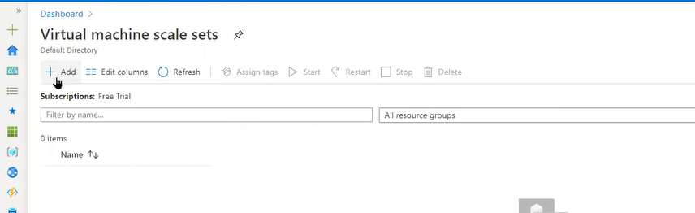

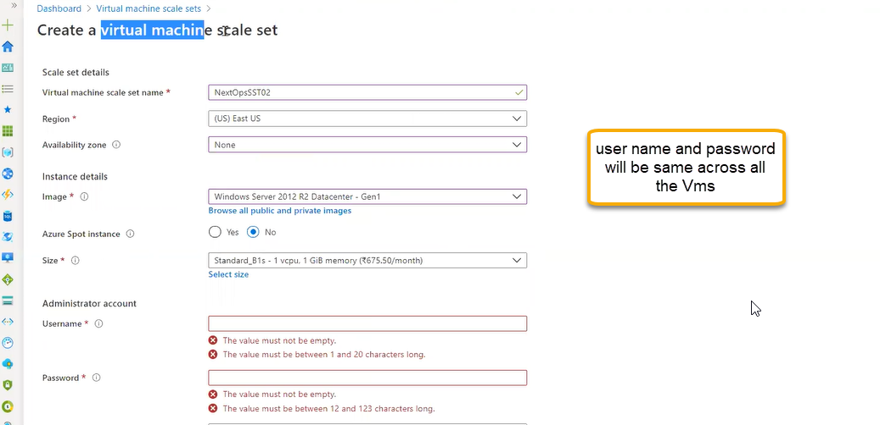

Click on the next

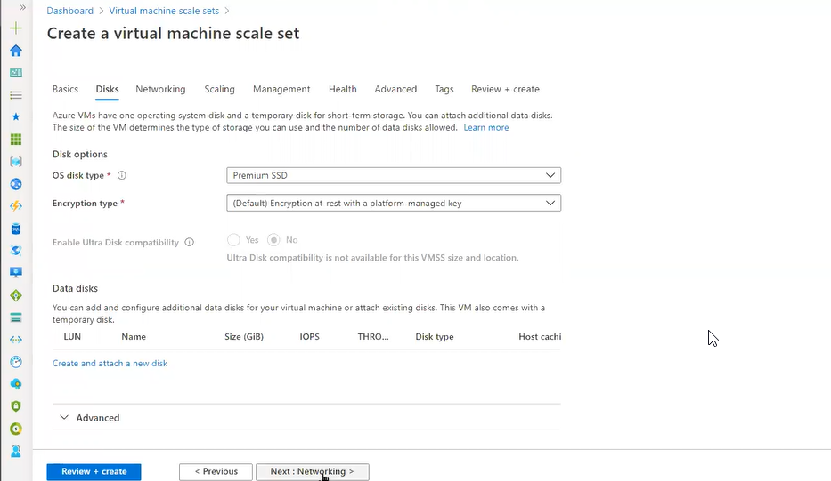

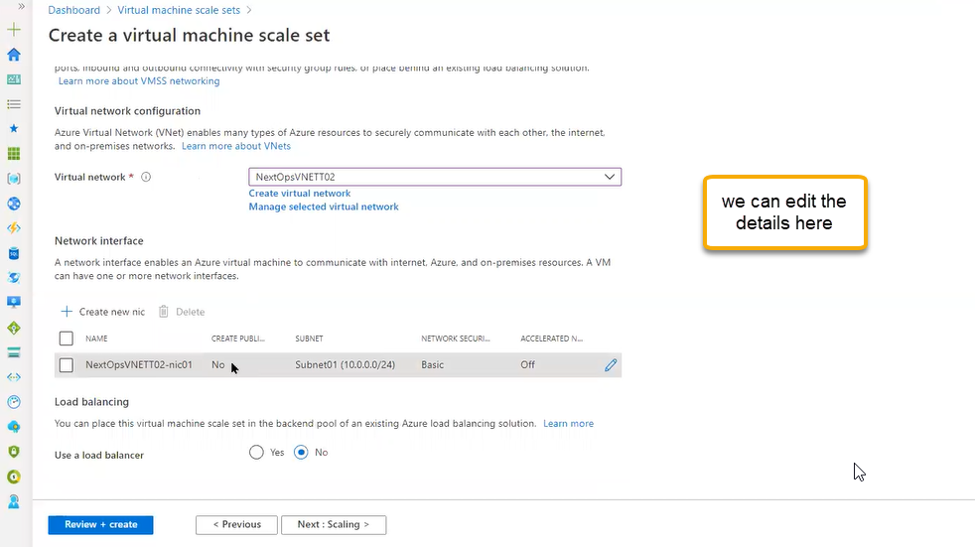

One single NIC is applied to all other network interface

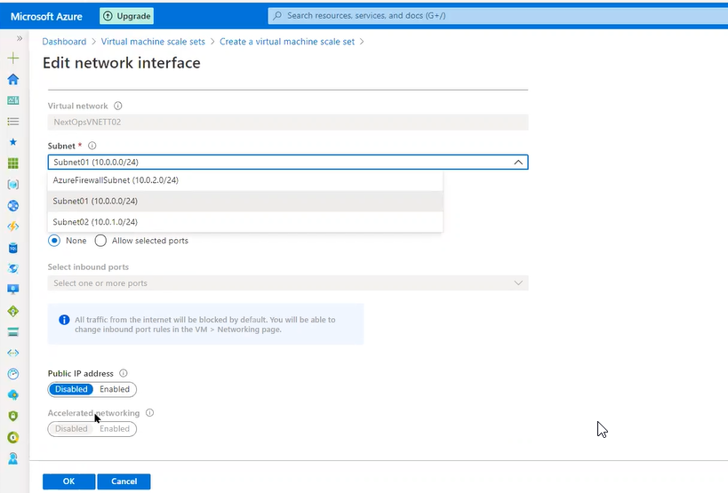

Manual scale set ( If scaling policy is set to be manual then in the initial instance count if you put 10 then 10 VM will be run ALL the Time)

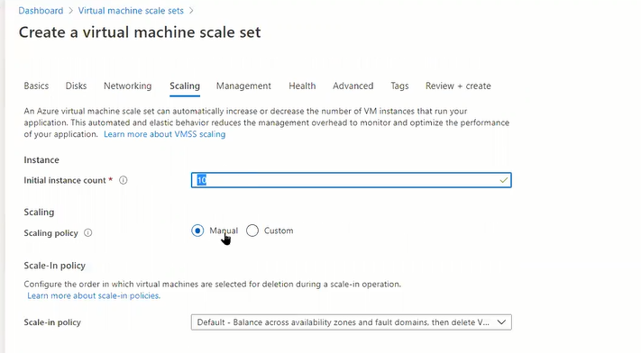

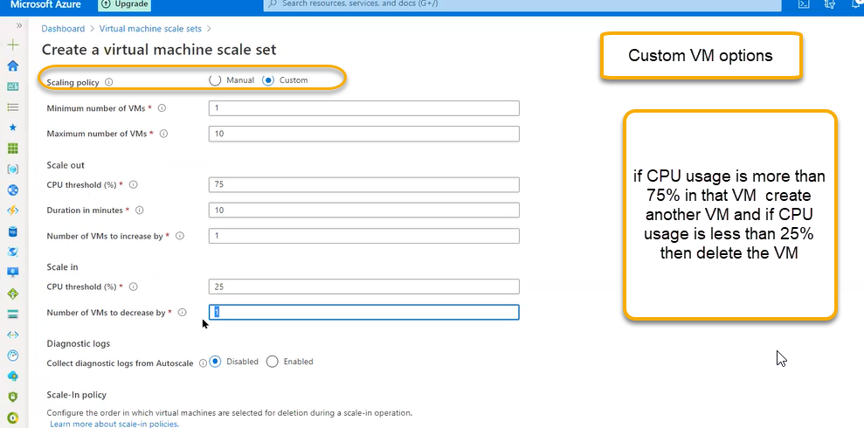

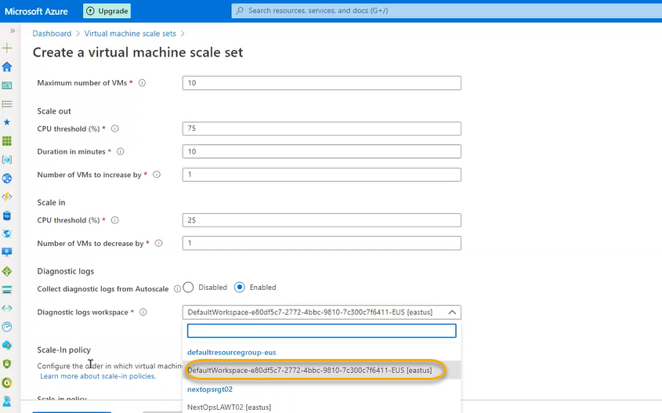

We can enable the option so that the logs will be stored in Monitor

Click on next > Management

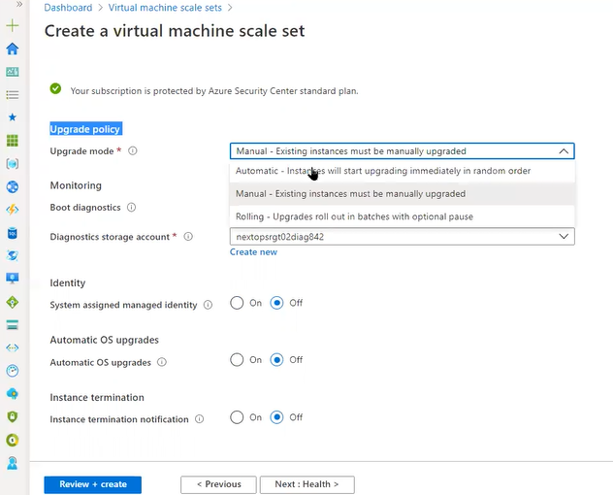

Click on health

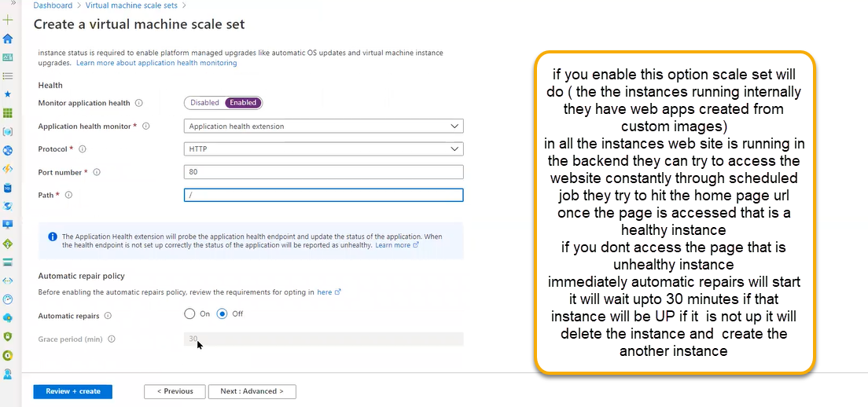

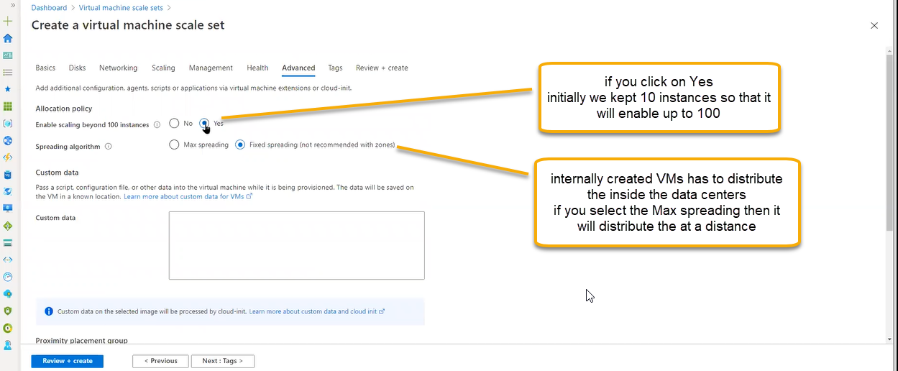

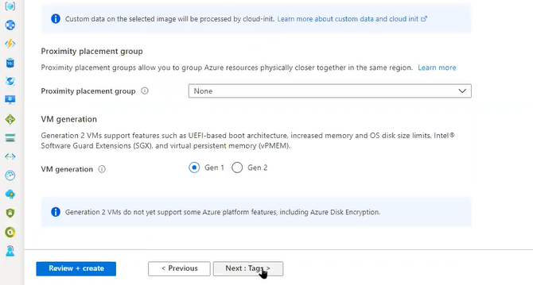

Click on Next and create

For free trail we have only four CPS will be allocated so create the instances/ VMS as 2.